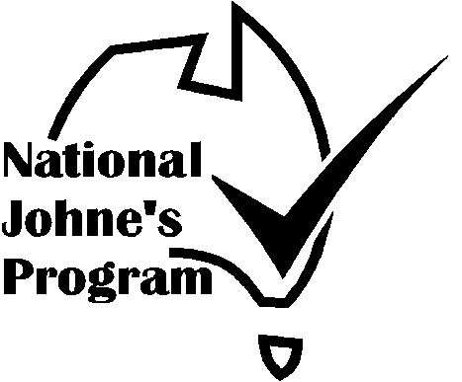

Australian Johne’s Disease
Market Assurance Program for Cattle
(CattleMAP)

SHOW, SALE & EXHIBITION
CERTIFICATE OF COMPLIANCE
“Provided by Federal Council of Agricultural Societies as part of the National JD Control Program”

This is to certify that

EVENT

VENUE | DATE
Co-ordinated by

COMMITTEE OF MANAGEMENT

COMMITTEE REPRESENTATIVE
and the organizer have undertaken to manage the event so as to maintain the status of exhibitors’ stock, compliant with the current CattleMAP guidelines.

AUDITOR

Address

Phone

Signature | Date
Cattle Audit – 10/09/09

Cattle MAP SHOW, SALE &
EXHIBITION VENUE AUDIT
‘Provided by Federal Council of Agricultural Societies as part of the National JD Control Program’

Compliance Checklist
It is recommended that an inspection be undertaken 2-3 weeks before the event so that defects can be corrected, exhibitors advised and venue audited immediately before the event. Auditor and Chief Steward should be familiar with and understand the relevant rules and regulations of the Cattle MAP.

Certificate of Compliance should be displayed for exhibitors to sight on arrival before unloading.

VENUE:

EVENT: | DATE:
VENUE MANAGEMENT COMMITTEE:

EVENT COMMITTEE REPRESENTATIVE:

AUDITOR:

ADDRESS:

DATE: | SIGNATURE:

- Entry requirements to minimise the risk of infectious animals attending the Show. (Tick the appropriate box)

MINIMUM DECLARATION
Exhibitor’s Declaration that the herd status is Non-Assessed (ie: the herd has not been assessed for Johne’s Disease and Johne’s Disease is not suspected in the herd).

DECLARATION & NEGATIVE TEST
Minimum as above plus testing negative of all exhibited cattle over 24 mths of age. Where the cattle are less than 2 years of age the dam will be tested.

CHECK TESTED (CT), BEEF ONLY, BEEF CATTLE TRADE ASSURANCE SCHEME (BC-TAS), DAIRY BJD SCORE 7 OR HIGHER
Only entry from these and higher status herds (including CattleMAP herds and herds from Free and Protected zones)

MN STATUS OR EQUIVALENT
Only entry of MN1 or higher status herds assessed under the CattleMAP (Note: Herds in Free and Protected Zones have a status equivalent at least to MN1).

Cattle MAP SHOW, SALE & EXHIBITION VENUE COMPLIANCE AUDIT

2. Action to minimise the risk of infection spreading at the Show.
2.1 Previous stock use in last twelve months & date
Sheep
Goats
Camelids
Deer
Cattle
2.2 Decontamination procedure between events.
Comment
2.3 Inspection of site for faecal contamination.
Comment
Satisfactory | Yes/No

a. HOUSING STANDARDS:
a.1 Assessed cattle and non-assessed cattle are separated by a minimum distance of 2 metres or a solid wall 1 metre high. |  | Yes/No
Comment
a.2 Different coloured ear/tail tags are used to differentiate animals from assessed and non-assessed herds | (optional) | Yes/No
a.3 Signs used to identify areas that are restricted to Assessed Stock |  | Yes/No
Comment

b. HYGIENE STANDARDS:
b.1 Provision and instruction has been made to feed and water animals from containers with a minimum height of 45cm above ground. |  | Yes/No
Comment
b.2.1 All cattle will be tethered when not led or penned in allocated areas |  | Yes/No
Comment
b.2.2 Cattle will not be permitted to graze on grassed areas |  | Yes/No
Comment

Cattle MAP SHOW, SALE & EXHIBITION VENUE COMPLIANCE AUDIT

b.3.1 Provisions have been made to promptly remove faecal contamination in common areas. |  |  |  |  |  | Yes/No
Comment
b.3.2 Faeces and contaminated bedding will be removed to a place to which stock do not have access. |  |  |  |  |  | Yes/No
Comment
b.4 During pen cleaning cattle will be kept away from areas, fixtures or bedding that has been contaminated by other animals. |  |  |  |  |  | Yes/No
Comment
b.5 Provision has been made for a steward to inspect the exhibited cattle and any cattle exhibiting signs consistent with BJD will be isolated. |  |  |  |  |  | Yes/No
Comment
c. Advice to Exhibitors  c.1 All exhibitors have been advised of the above guidelines. |  |  |  |  |  | Yes/No
Comment
c.2 All exhibitors have been advised to thoroughly clean out trucks used to transport stock. |  |  |  |  |  | Yes/No
Comment
c.3 All exhibitors have been advised to separate cattle from assessed and non-assessed herds and have calves tethered or penned at all times.. |  |  |  |  |  | Yes/No
Comment
AUDIT SUMMARY  Provisions comply with Cattle MAP Guidelines |  |  |  |  |  | Yes/No
 |  |  | Description of Element
Non Compliance | Minor Defect
Non Compliance | Major Defect
Non Compliance | Critical Defect
Chief Steward signs that he/she understands the above listed requirements and that these requirements will be met during the show.
Chief Steward Signature |  |  |  | Date:
Auditor Signature |  |  |  | Date:

