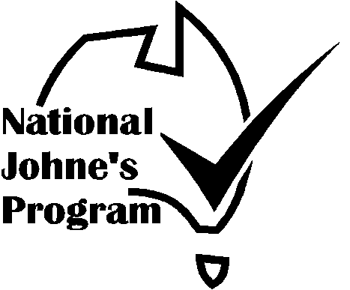

Australian Johne’s Disease
Market Assurance Program for Alpacas
(AlpacaMAP)

SHOW, SALE & EXHIBITION
CERTIFICATE OF COMPLIANCE
“Provided by Agricultural Shows Australia as part of the National JD Program”

This is to certify that

EVENT

VENUE | DATE
Co-ordinated by

COMMITTEE OF MANAGEMENT

COMMITTEE REPRESENTATIVE
and the organizer have undertaken to manage the event so as to maintain the status of exhibitors’ stock, compliant with the current Alpaca MAP guidelines.

AUDITOR

Address

Phone

Signature | Date
Alpaca Audit – 10/09/09

Alpaca MAP SHOW, SALE &
EXHIBITION VENUE AUDIT
‘Provided by Agricultural Shows Australia as part of the National JD Program’

Compliance Checklist
It is recommended that an inspection be undertaken 2-3 weeks before the event so that defects can be corrected, exhibitors advised and venue audited immediately before this event. Auditor and Chief Steward should be familiar with and understand the relevant rules and regulations of the AlpacaMAP.
Certificate of Compliance should be displayed for exhibitors to sight on arrival before unloading.

VENUE:

EVENT: | DATE:
VENUE MANAGEMENT COMMITTEE:

EVENT COMMITTEE REPRESENTATIVE:

AUDITOR:

ADDRESS:

DATE: | SIGNATURE:

- Entry requirements to minimise the risk of infected animals attending the Show. (Tick the appropriate box)

MINIMUM DECLARATION
Exhibitor’s Declaration that the herd status is Non-Assessed (ie: the herd has not been assessed for Johne’s Disease and Johne’s Disease is not suspected in the herd).

DECLARATION & NEGATIVE TEST
Minimum as above plus testing negative of all exhibited alpaca over 12mths of age. Where the alpaca are less than 1 year of age the dam will be tested.

CHECK TESTED (CT) or Q-ALPACA
Only entry of CT. Q-Alpaca and higher status herds (including AlpacaMAP herds and herds from Free and Protected Zones).

MN STATUS OR EQUIVALENT
Only entry of MN1 or higher status herds assessed under the AlpacaMAP (Note: Herds in Free and Protected Zones have a status equivalent at least to MN1).

Alpaca MAP SHOW, SALE & EXHIBITION VENUE COMPLIANCE AUDIT

2. Action to minimise the risk of infection spreading at the Show.
2.1 Previous stock use in last twelve months & date
Sheep
Goats
Camelids
Deer
Cattle
2.2 Decontamination procedure between events.
Comment:
2.3 Inspection of site for faecal contamination.
Comment:

Satisfactory | Yes/No

a. HOUSING STANDARDS:
a.1 Assessed alpaca and non-assessed alpaca are separated by a minimum distance of 2 metres or a solid wall 1 metre high. |  | Yes/No
Comment:
a.2 Different coloured ear/tail tags are used to differentiate animals from assessed and non-assessed herds | (optional) | Yes/No
a.3 Signs used to identify areas that are restricted to Assessed Stock. |  | Yes/No
Comment

b. HYGIENE STANDARDS:
b.1 Provision and instruction has been made to feed and water animals from containers with a minimum height of 45cm above ground. |  | Yes/No
Comment:
b.2.1 All alpaca will be led when not penned in allocated areas. |  | Yes/No
Comment:
b.2.2 Alpaca will not be permitted to graze on grassed areas |  | Yes/No
Comment:

Alpaca MAP SHOW, SALE & EXHIBITION VENUE COMPLIANCE AUDIT

b.3.1 Provisions have been made to promptly remove faecal contamination from common areas. |  |  |  |  | Yes/No
Comment:
b.3.2 Faeces and contaminated bedding will be removed to a place to which  stock do not have access. |  |  |  |  | Yes/No
Comment:
b.4 During pen cleaning alpaca will be kept away from areas, fixtures or bedding  that has been contaminated by other animals |  |  |  |  | Yes/No
Comment:
b.5 Provision has been made for a steward to inspect the exhibited alpaca and  any alpaca exhibiting signs consistent with BJD will be isolated. |  |  |  |  | Yes/No
Comment:
c. Advice to Exhibitors  c.1 All exhibitors have been advised of the above guidelines. |  |  |  |  | Yes/No
Comment:
c.2 All exhibitors have been advised to thoroughly clean out vehicles & trailers  used to transport stock. |  |  |  |  | Yes/No
Comment:
c.3 All exhibitors have been advised to separate alpaca from assessed and non-assessed herds and have alpaca tethered or penned at all times. |  |  |  |  | Yes/No
Comment:
AUDIT SUMMARY  Provisions comply with AlpacaMAP Guidelines |  |  |  |  | Yes/No
 |  | Description of Element
Non Compliance | Minor Defect
 | Major Defect
 | Critical Defect
Chief Steward signs that he/she understands the above listed requirements and that these requirements will be met during the show.
Chief Steward Signature |  |  | Date:
Auditor Signature |  |  | Date:

