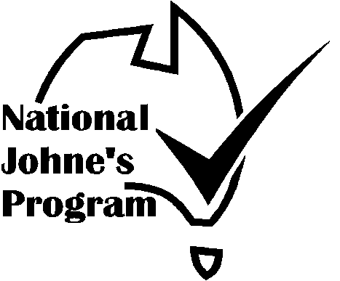

Australian Johne’s Disease
Market Assurance Program for Goats
(Goat MAP)

SHOW, SALE & EXHIBITION
CERTIFICATE OF COMPLIANCE
“Provided by Agricultural Shows Australia as part of the National JD Program”

This is to certify that

EVENT

VENUE | DATE
Co-ordinated by

COMMITTEE OF MANAGEMENT

COMMITTEE REPRESENTATIVE
and the organizer have undertaken to manage the event so as to maintain the status of exhibitors’ stock, compliant with the current GoatMAP guidelines.

AUDITOR

Address

Phone

Signature | Date
Goat Audit – 10/09/09
Goat MAP SHOW, SALE &
EXHIBITION VENUE AUDIT
‘Provided by Agricultural Shows Australia as part of the National JD Program’

Compliance Checklist
It is recommended that an inspection be undertaken 2-3 weeks before the event so that defects can be corrected, exhibitors advised and venue audited immediately before the event. Auditor and Chief Steward should be familiar with and understand the relevant rules and regulations of the Goat MAP.
Certificate of Compliance should be displayed for exhibitors to sight on arrival before unloading.

VENUE:

EVENT: | DATE:
VENUE MANAGEMENT COMMITTEE:

EVENT COMMITTEE REPRESENTATIVE:

AUDITOR:

ADDRESS:

DATE: | SIGNATURE:

- Entry requirements to minimise the risk of infected animals attending the Show. (Tick the appropriate box)

MINIMUM DECLARATION
Exhibitor’s Declaration that the herd status is Non-Assessed (ie: the herd has not been assessed for Johne’s Disease and Johne’s Disease is not suspected in the herd).

DECLARATION & NEGATIVE TEST
Minimum as above plus testing negative of all exhibited goats over 12mths of age.

CHECK TESTED
Only entry of CT or higher status herds (including GoatMAP herds from Free and Protected Zones declared for goats).

MN STATUS OR EQUIVALENT
Only entry of MN1 or higher status herds assessed under the GoatMAP (Note: Herds in Free and Protected Zones declared for goats have a status equivalent at least to MN1).

As goats are affected by both Bovine and Ovine Johne’s disease for which Zone boundaries may differ, please check that the Protected Zones from which goats originate have been declared for goats.
GoatMAP SHOW, SALE & EXHIBITION VENUE COMPLIANCE AUDIT
2. Action to minimise the risk of infection spreading at the Show.
2.1 Previous stock use in last twelve months & date
Goats
Sheep
Cattle
Camelids
Deer
2.2 Decontamination procedure between events.
Comment
2.3 Inspection of site for faecal contamination.
Comment

Satisfactory | Yes/No

a. HOUSING STANDARDS:
a.1 Assessed goats and non-assessed goats are separated by a minimum distance of 2 metres or a solid wall 1 metre high. |  | Yes/No
Comment
a.2 Different coloured ear tags are used to differentiate animals from assessed and non-assessed herds | (optional) | Yes/No
a.3 Signs used to identify areas that are restricted to Assessed Stock |  | Yes/No
Comment

b. HYGIENE STANDARDS:
b.1 Provision and instruction has been made to feed and water animals from containers with a minimum height of 30cm above ground. |  | Yes/No
Comment
b.2.1 All goats will be tethered when not led or penned in allocated areas. |  | Yes/No
Comment
b.2.2 Goats will not be permitted to graze on grassed areas |  | Yes/No
Comment

GoatMAP SHOW, SALE & EXHIBITION VENUE COMPLIANCE AUDIT

b.3.1 Provisions have been made to promptly remove faecal contamination from common areas. |  |  |  |  |  | Yes/No
Comment
b.3.2 Faeces and contaminated bedding will be removed to a place to which stock  do not have access. |  |  |  |  |  | Yes/No
Comment
b.4 During pen cleaning goats will be retained away from areas, fixtures or bedding that has been contaminated by other animals |  |  |  |  |  | Yes/No
Comment
b.5 Provision has been made for a steward to inspect the exhibited goats and any goats exhibiting signs consistent with OJD will be isolated. |  |  |  |  |  | Yes/No
Comment
c. Advice to Exhibitors  c.1 All exhibitors have been advised of the above guidelines. |  |  |  |  |  | Yes/No
Comment
c.2 All exhibitors have been advised to thoroughly clean out trucks used to transport stock. |  |  |  |  |  | Yes/No
Comment
c.3 All exhibitors have been advised to separate goats from assessed and non-assessed herds and have goats tethered or penned at all times.. |  |  |  |  |  | Yes/No
Comment Click here to enter text.
AUDIT SUMMARY  Provisions comply with GoatMAP Guidelines |  |  |  |  |  | Yes/No
 |  |  | Description of Element
Non Compliance | Minor Defect
 | Major Defect
 | Critical Defect
Chief Steward signs that he/she understands the above listed requirements and that these requirements will be met during the show.
Chief Steward Signature |  |  |  | Date:
Auditor Signature |  |  |  | Date:

